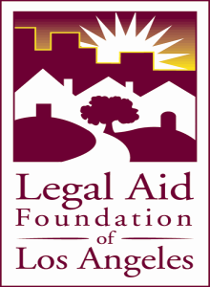
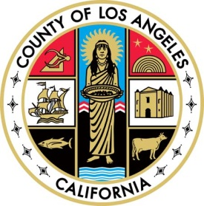

The Domestic Violence Council Immigration Committee in collaboration with the Legal Aid Foundation of Los Angeles and Neighborhood Legal Services of Los Angeles County will present the 3rd Annual Immigration & Domestic Violence Symposium. This event is free.

“STRATEGIES TO UNDERSTAND & ASSIST IMMIGRANT TEENS”

DATE: Wednesday, October 31, 2012
TIME: 8:30 am to 12:30 pm
PLACE: THE CALIFORNIA ENDOWMENT
1000 N. Alameda Street, Los Angeles, CA 90012
Redwood Room

WHAT YOU WILL How neurobiology affects teens’ decision-making skills
LEARN: & practical strategies for working with immigrant teens

WORKSHOPS: • SOCIAL SERVICE TRAINING
• PRO BONO ATTORNEY TRAINING

WHO WILL Executive directors, counselors, legal advocates and
BENEFIT: attorneys. CEUs will be available CLE/LMFT and LCSW. MCLE will be available for pro bono attorneys. Space is limited and is strictly for individuals working with or providing services to immigrants.

Parking is available behind The California Endowment. Please let the parking attendant know you are attending the Immigration & DV Symposium.

